**User Manual**

**Module - Restaurant (Administrator)**

**June 2022, Version-1.0**



**Sustainable Outreach and Universal Leadership Limited**

**Sign off Date     Signature Client Signature Consulting**

Table of Contents

[Module: Restaurant 3](https://docs.google.com/document/d/198pC5pz8fhu2hql7Lhit7WpfHo7yllOk/edit" \l "heading=h.1fob9te)

[1. Restaurant 3](https://docs.google.com/document/d/198pC5pz8fhu2hql7Lhit7WpfHo7yllOk/edit" \l "heading=h.3znysh7)  
2. Restaurant Menu 4

1. Restaurant Order Entry 6

4. Restaurant Reservation 7

5. Restaurant Table 8

6. Sales Invoice 9

1. **Restaurant**

Restaurant is a master doctype linked with other doctypes like Restaurant Menu, Restaurant reservation, Restaurant table and Sales Invoice. Fields like Company, Active menu, Default Tax template on the food menu, Address of the Restaurant can be linked from this doctype.

**1.1 To access the Sales Invoice list, go to:**

Home > Restaurant Order > Your Shortcuts > Restaurant

**1.2 Prerequisite**

* Company
* Restaurant Menu
* Sales Taxes and Charges Template

**1.3 How to Create a Restaurant?**

1. Go to Restaurant and Click on Add Restaurant.

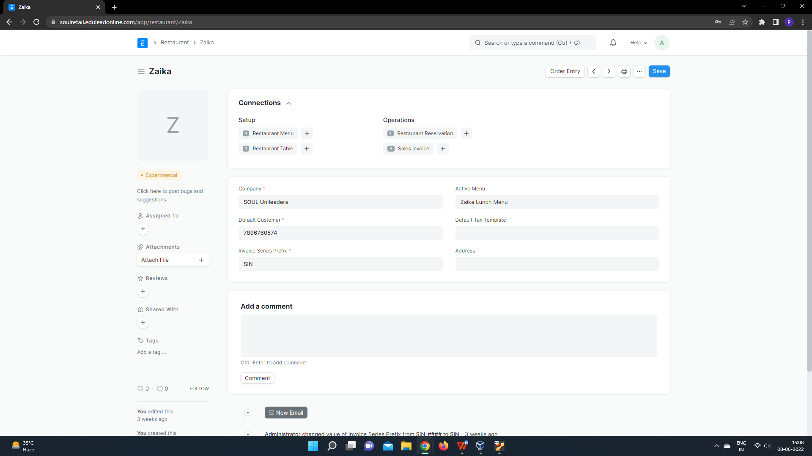

1. Enter Name and Invoice Series Prefix.
2. Select Company, Active Menu, default Tax template and adress from the list that appears.
3. Save.
4. **Restaurant Menu**

Restaurant menu is a doctype where we add food menu or items along with their price for a specific restaurant.

**2.1 To access the Sales Invoice list, go to:**

Home > Restaurant Order > Your Shortcuts > Restaurant Menu

**2.2 Prerequisite**

* Restaurant
* Item

**2.3 How to Create a Restaurant?**

1. Go to Restaurant Menu and Click on Add Restaurant Menu.

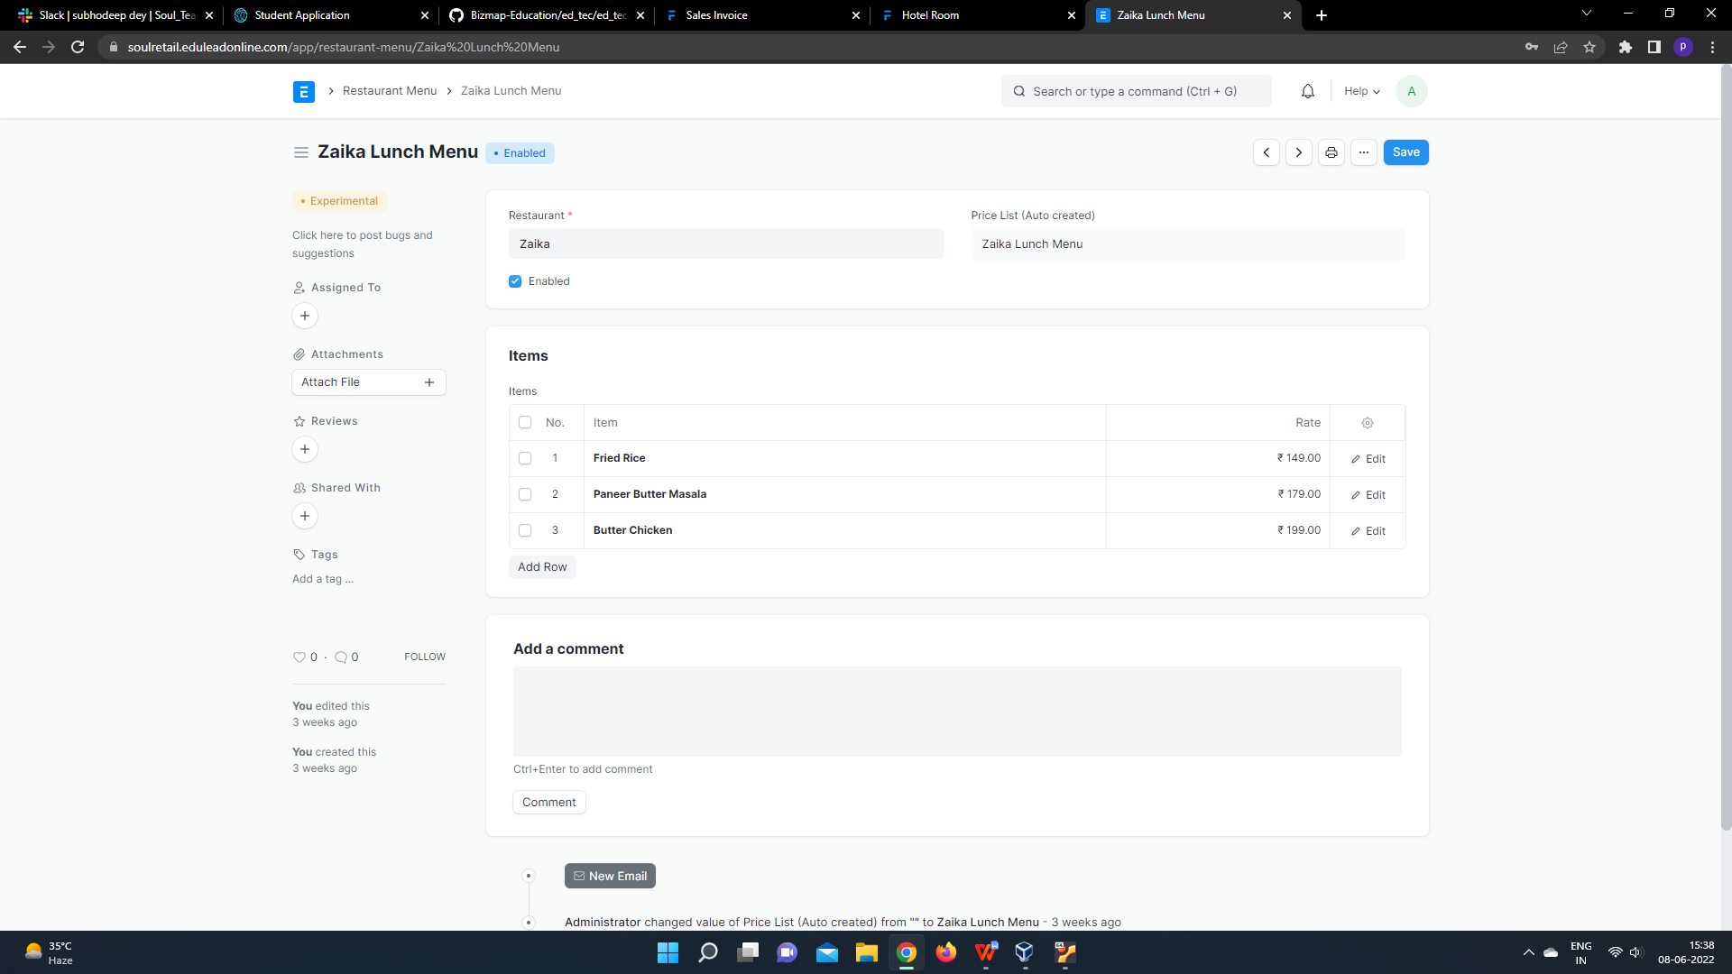

1. Enter Name of menu.
2. Select the restaurant name appearing from the list.
3. Add dishes in the Items table and add the price of the dishes along with it.
4. Save.
5. **Restaurant Order Entry**

The Restaurant Order Entry is the screen where the waiters will punch in orders related to a particular table.

This screen makes it easy for the waiters in your restaurant to punch in orders from various tables.

**3.1 To access the Sales Invoice list, go to:**

Home > Restaurant Order > Your Shortcuts > Restaurant Order Entry

**3.2 Prerequisite**

Restaurant Table

Item

**3.3 How to Create a Restaurant?**

1. Go to Restaurant Order Entry and Click on Add Restaurant Order Entry.

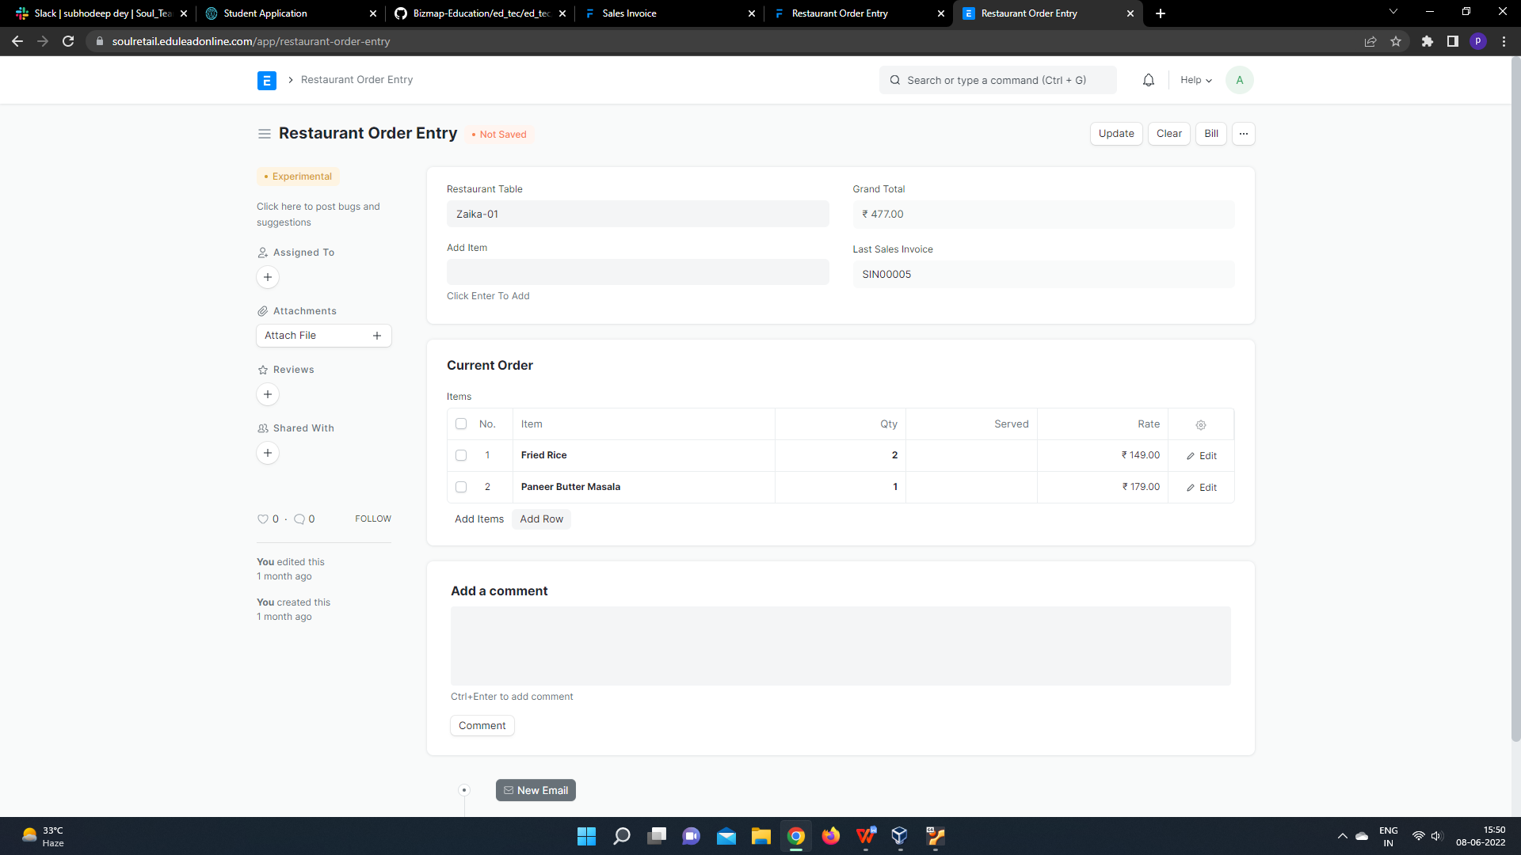

2. When the guest places an order, the waiter will select the table number and add the items in the Order Entry.

3. To place an order you can select an item and click the enter key so that the item will be updated in the items table.

This can be changed until it is time for the bill. Unless you bill a table, you can change the items and they will automatically appear when you select the table ID.

### **Billing**

When it is time for billing, you just choose the bill and you can select the customer and mode of payment. On saving, a Sales Invoice is generated and the order section becomes empty.

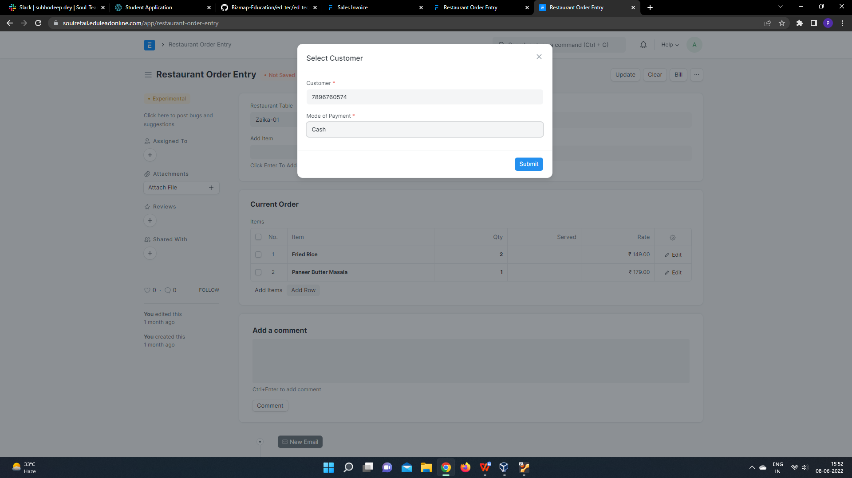

To print the invoice, you can click on the Invoice Link and print the invoice.

1. **Restaurant Reservation**

Restaurant Reservation doctype is used for booking table in a restaurant by Customers by entering their details like Customer name, Contact number, No of people for which reservation is needed and from time and to time of restaurant.

**4.1 To access the Sales Invoice list, go to:**

### Home > Restaurant Order > Your Shortcuts > Restaurant Reservation

**4.2 Prerequisite**

Restaurant

Customer

**4.3 How to Create a Restaurant?**

1. Go to Restaurant Reservation and Click on Add Restaurant Reservation.

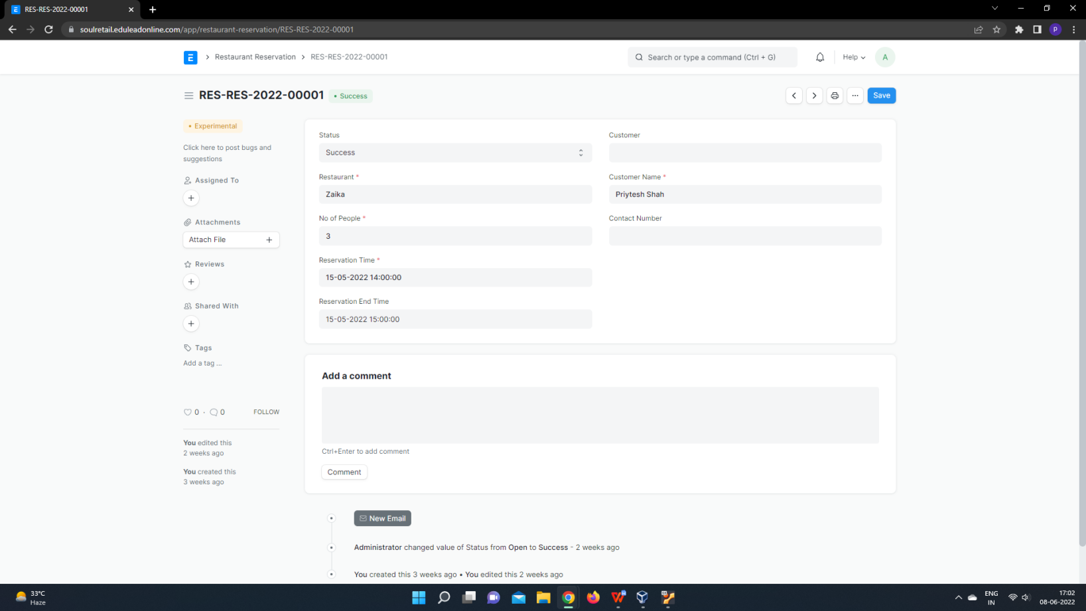

2. Enter Customer Name, Contact number, No of people and Reservation Time, Reservation End time for reservation.

4. save.

1. **Restaurant Table**

Restaurant table is a master doctype where you can declare the table in a restaurant and their seating capacity which would be linked with transactions like Order and reservation.

**5.1 To access the Sales Invoice list, go to:**

### Home > Restaurant > Your Shortcuts > Restaurant Table

**5.2 Prerequisite**

Restaurant

**5.3 How to Create a Restaurant?**

1. Go to Restaurant Table and Click on Add Restaurant Table.

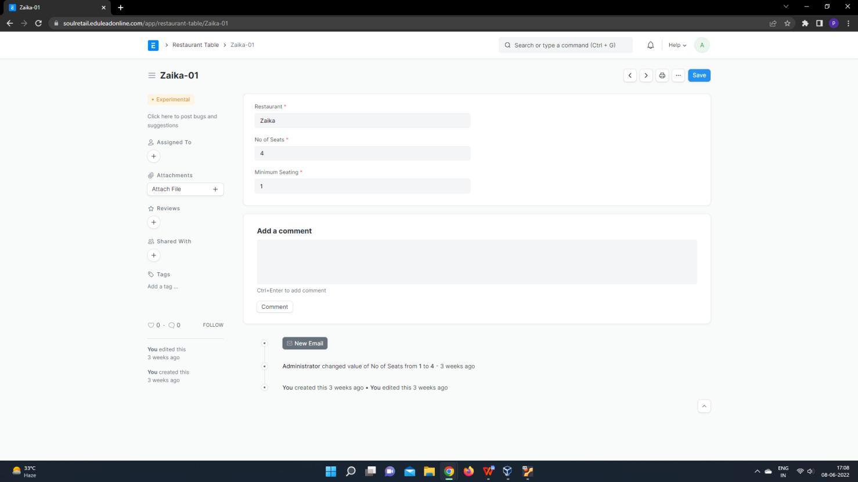

2. Select Restaurant from the list that appears.

3. Enter no of seats and minimum seating.

4. Save.

1. **Sales Invoice**

**A Sales Invoice is a bill that you send to your Customers against which the Customer makes the payment.**

Sales Invoice is an accounting transaction. On submission of Sales Invoice, the system updates the receivable and books income against a Customer Account.

To access the Sales Invoice list, go to:

Home > Retail-Billing System>Reports & Masters > Masters > Sales Invoice

## **6.8.1. Prerequisites**

Before creating and using a Sales Invoice, it is advised to create the following first:

* Item
* Customer

## **6.8.2. How to create a Sales Invoice**

A Sales Invoice is usually created from a Sales Order or a Delivery Note. The Customer's Item details will be fetched into the Sales Invoice. However, you can also create a Sales Invoice directly, for example, a POS invoice.

To fetch the details automatically in a Sales Invoice, click on the ****Get Items from****. The details can be fetched from a Sales Order, Delivery Note, or a Quotation.

For manual creation, follow these steps:

1. Go to the Sales Invoice list and click on New.
2. Select the Customer.
3. Set the Payment Due Date.
4. In the Items table, select the Items and set the quantities.
5. The prices will be fetched automatically if [Item Price](https://docs.erpnext.com/docs/v13/user/manual/en/stock/item-price) is added, else add a price in the table.
6. The posting date and time will be set to current, you can edit after you tick the checkbox below Posting Time to make a backdated entry.
7. Save and Submit.

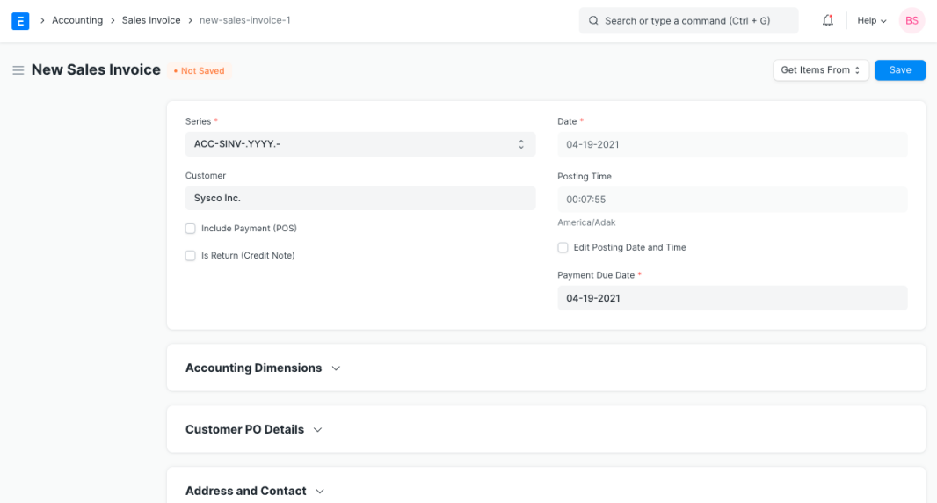

## **6.8.2.1 Additional options when creating a Sales Invoice**

* ****Include Payment (POS)****: If this invoice is for retail sales / Point of Sale. [Know more here](https://docs.erpnext.com/docs/v13/user/manual/en/accounts/sales-invoice" \l "324-pos-invoices).
* ****Is Return Credit Note****: Tick this if the customer has returned the Items.

## **6.8.2.2 Statuses**

These are the statuses that are auto-assigned to Sales Invoice.

* ****Draft****: A draft is saved but yet to be submitted.
* ****Submitted****: The invoice is submitted to the system and the general ledger has been updated.
* ****Paid****: Customer has made the payment and a [Payment Entry](https://docs.erpnext.com/docs/v13/user/manual/en/accounts/payment-entry) has been submitted.
* ****Unpaid****: Invoice is generated but payment is pending but within the payment due date.
* ****Overdue****: Payment is pending beyond the payment due date.
* ****Canceled****: The Sales Invoice is canceled due to any reason. Once an invoice is canceled, it's impact on Account and Stock is undone.
* ****Credit Note Issued****: The Item is returned by the Customer and a [Credit Note](https://docs.erpnext.com/docs/v13/user/manual/en/accounts/credit-note) is created against this invoice.
* ****Return****: It is assigned to Credit Note created against the original Sales Invoice. Though you can also create a standalone Credit Note.
* ****Unpaid and Discounted****: Payment is pending and any ongoing subscription has been discounted using [Invoice Discounting](https://docs.erpnext.com/docs/v13/user/manual/en/accounts/invoice_discounting).
* ****Overdue and Discounted****: Payment is pending beyond the payment due date and any ongoing subscription has been discounted using [Invoice Discounting](https://docs.erpnext.com/docs/v13/user/manual/en/accounts/invoice_discounting).